Romibo Construction Manual

Valentin Darre and Adam Warburton

**Part 1: Head Construction**

**Materials Needed:**

* Plastic Romibo Parts (20 – blinking eyelids model) (16 – earlier model)
* Phillips Screwdrivers (2) (Size 1 and Size 00)
* Screws (18) (various size)
  + 4 Servo (s2)
  + 4 Satellite Boards (s3)
  + 2 Servo Arm (s1)
  + 8 Switches (s4)
* Wi-Fly Board
* Satellite Boards (2)
* Touch Switches (4)
* Fiber Optic Cables (2)
* Rubber Rings (4)
* Resistor Servo HS-485HB (Servo)
* Eye Strut (L)
* Wire (J)
* Paper Eyelids

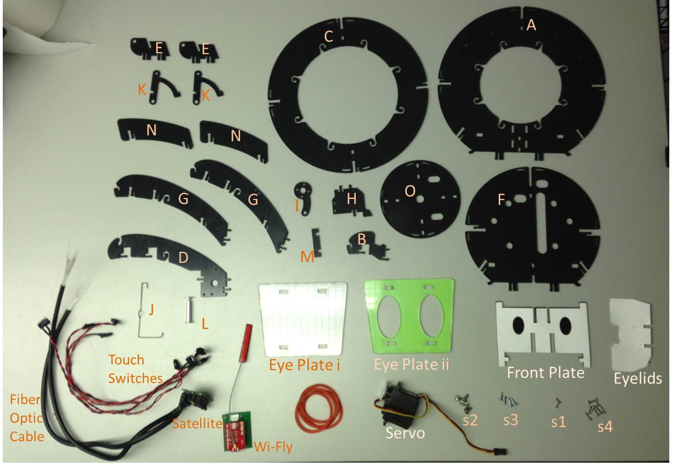



**Time Needed: 30 Minutes**

**Steps:**

Connect Part A to Part B

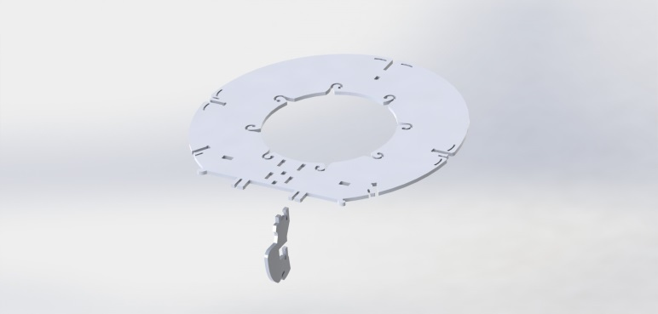

Connect Part C to Part B

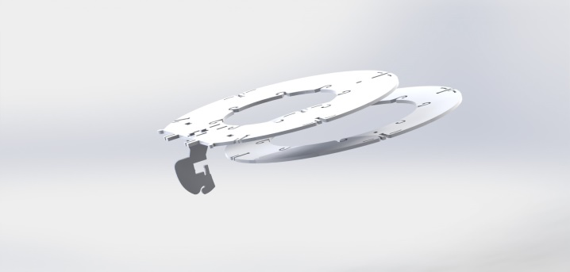

Connect Part D to Parts A and C

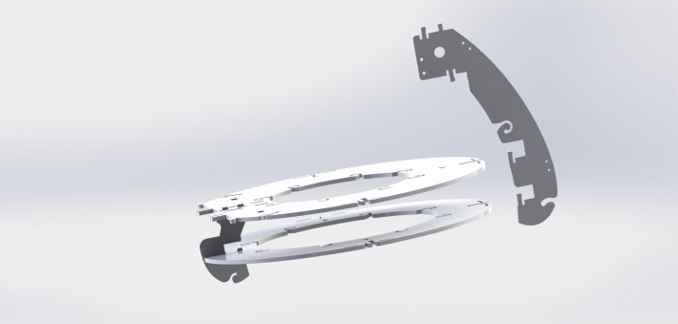

Connect 2 of part E to Part A

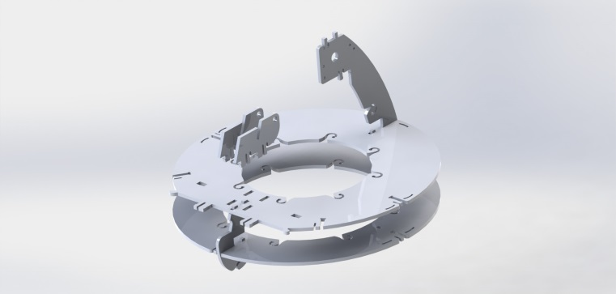

Connect Part F to Part D

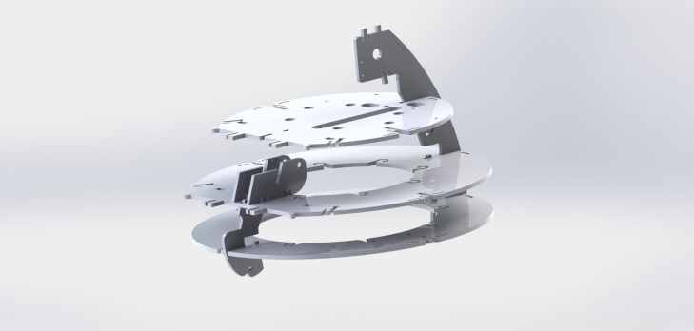

Connect 2 of Part G to either side.

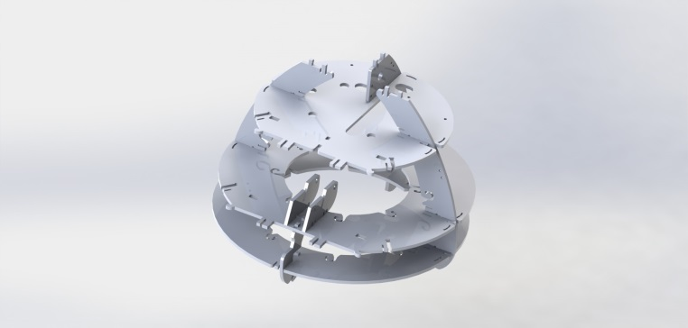

E

Connect Part H to Part F

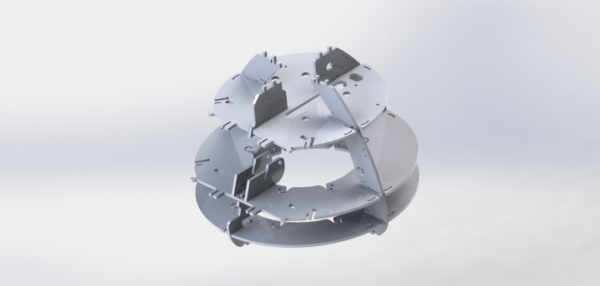

Make sure that white plastic wheel is centered.

Put Servo Arm (I) on the Servo

With Servo facing you, and the cable to the right, attach the servo arm facing down.

Use two screws (s1) to attach arm.

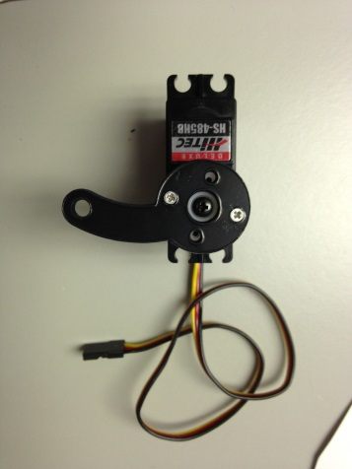

Place Servo on top with arm going through opening.

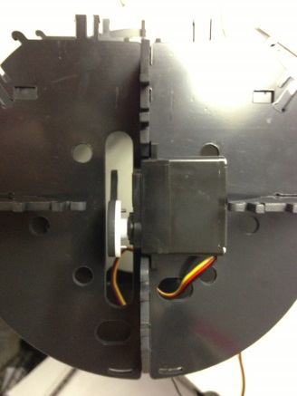

Screw Servo In (s2)

Insert Metal Wire (J) through Servo Arm hole (I).

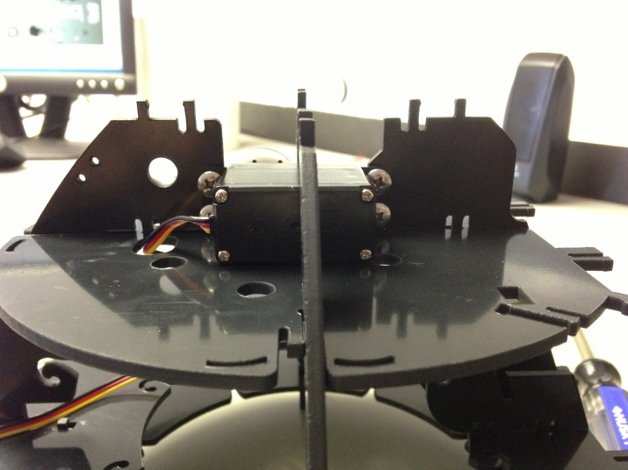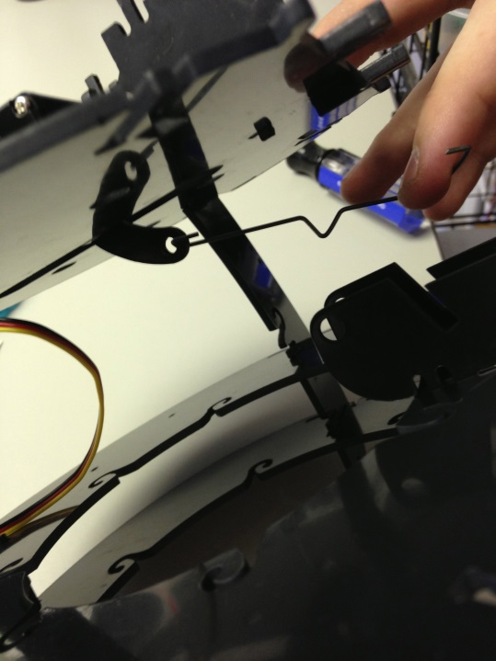

Slide Parts K around Wire (J)

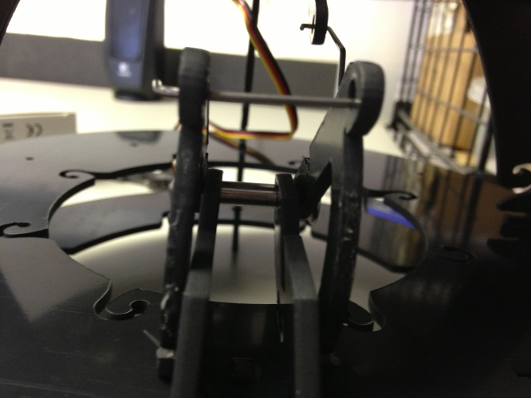

Feed Eye Strut (L) through Bottom hole of parts K and hole in part E.

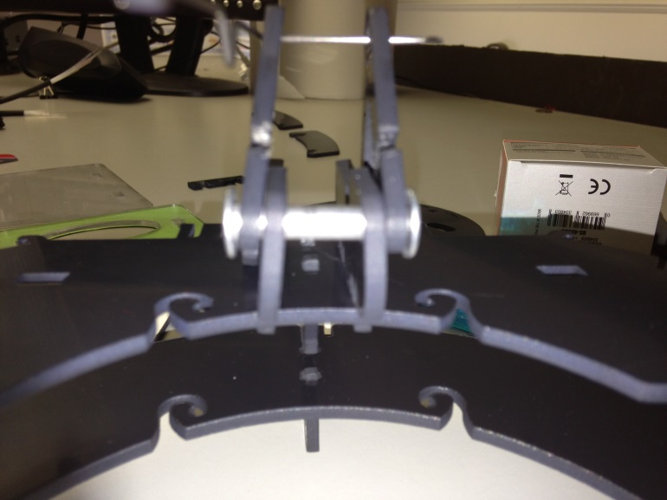

Attach Part M to back part of both K pieces.

Gently push Eyelid Mechanism all the way back.

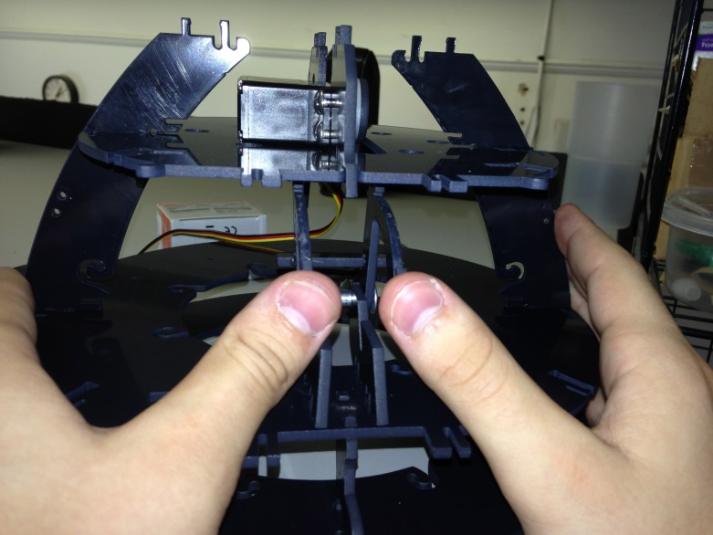

Attach Front Plate (top part first) to holes in part F.

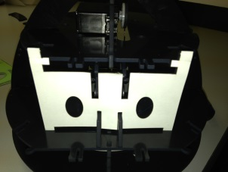

Push plate back until it clicks into place in bottom.

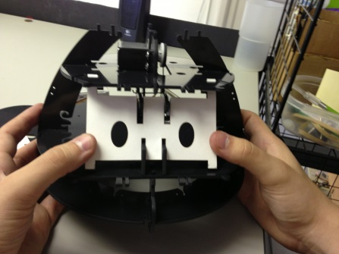

Pull eyelid mechanism forward and place eyelids

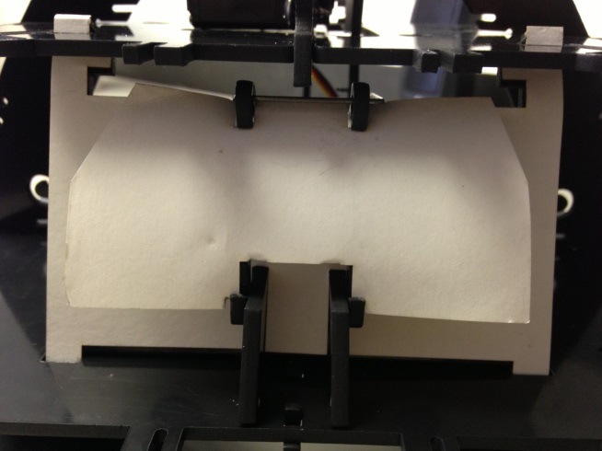

Attach Parts N to either side of robot.

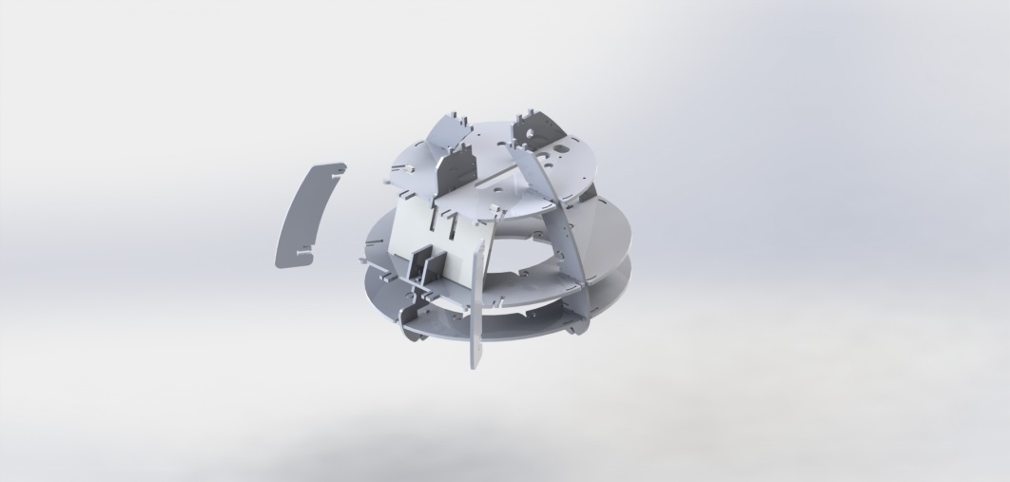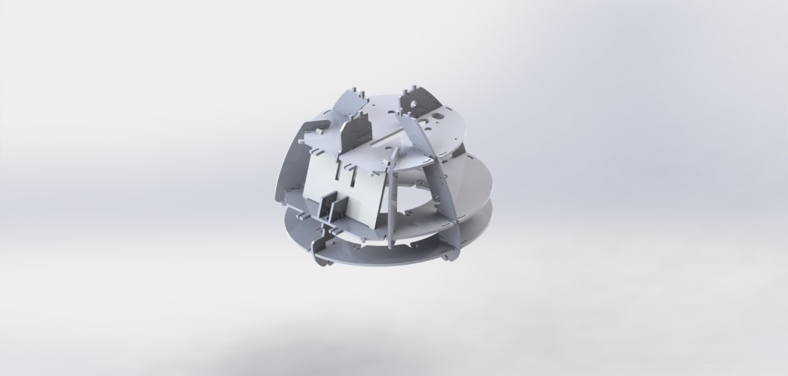

Attach Eye Plates (flat one (i) first). (your Eye Plate ii may be clear)

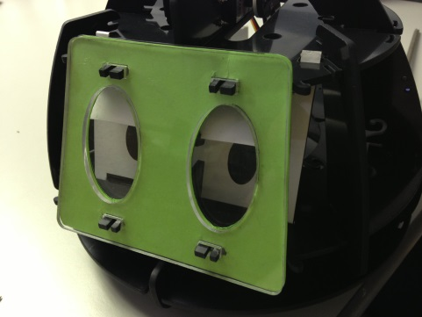

Screw in Satellite Board with fiber optic cables to the back of the robot.

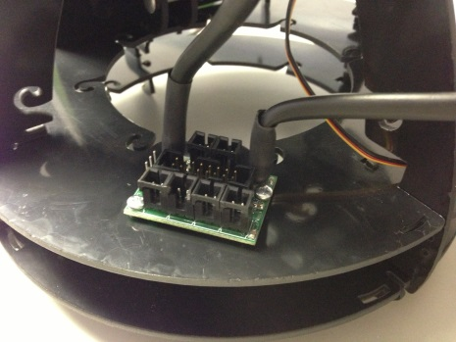

Looking at robot from behind, grab the left-most fiber optic cable and feed it through back most circle hole.

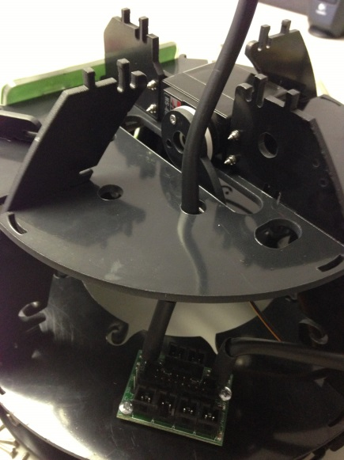

Then feed the same cable down through the next hole up.

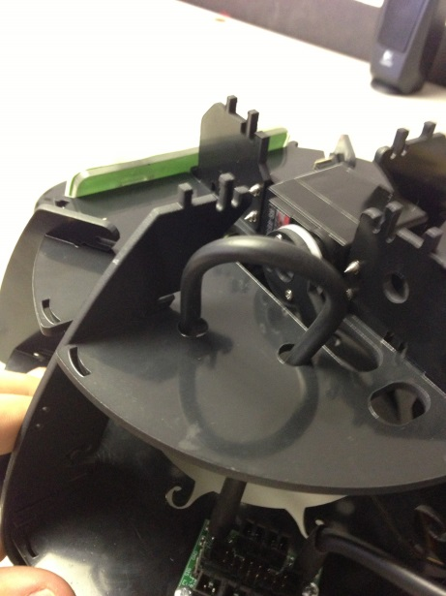

Feed cable up through the next hole up.

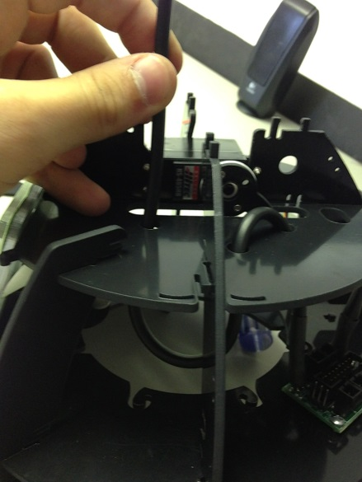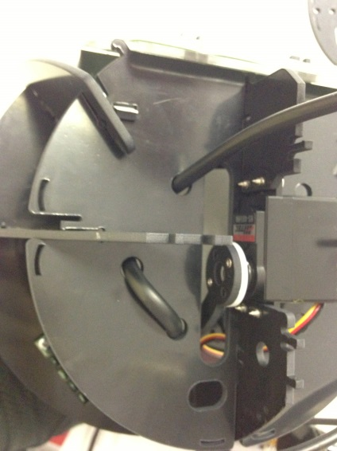

Repeat process with right most fiber optic cable, mirroring holes used by the left one

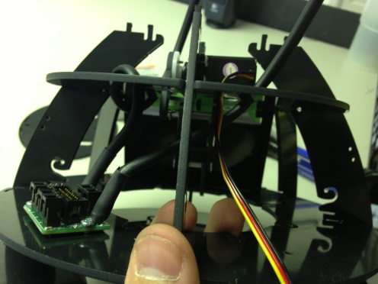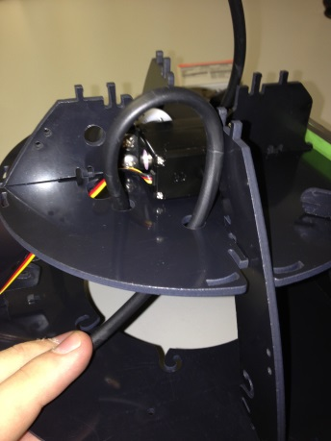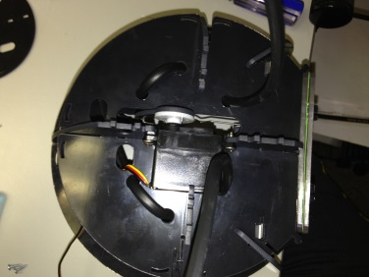

Attach Final Plate (Part O) Be sure to feed Fiber Optic Cables through the holes.

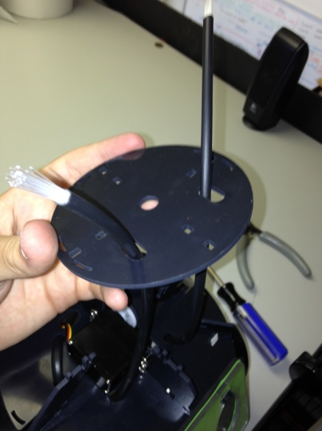

Attach Wi-Fly board and screw in (s3).

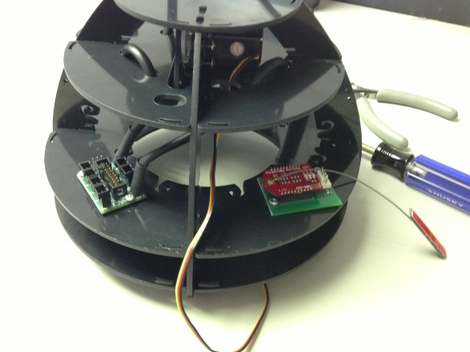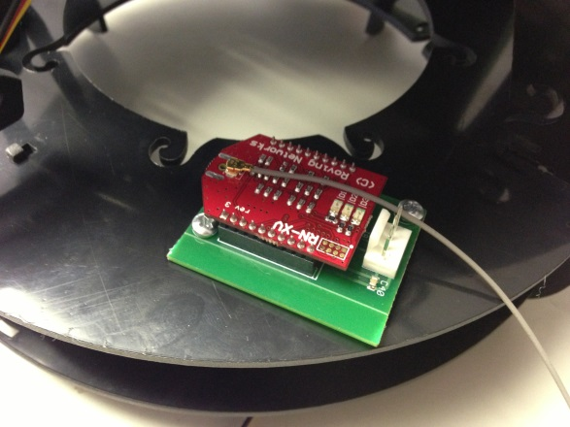

Screw in Touch Switches (s4).

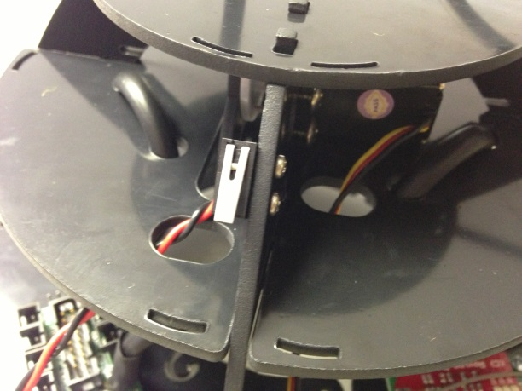

**Part 2: Base Construction**

**Materials Needed:**

* Plastic Romibo Parts (16)
* Hot Glue Gun
* Screwdriver
* Screws (# varies) (14 for R3 model)
* Speaker
* Infared Sensor
* Battery Pack with on/off switch
* Arduino Board with Romibo Shield

Steps

Build Neck by sliding B1 and B2 into A1 and A2

Slide A2 on to close.

***solid works files****

Slide neck assembly into top plate C

Add Servo Arms to Servos, then attach to B2 ensuring that servo arms are curved inward.

***dropbox photo****

Screw Servos into B1

Put motors through holes in plates D1 and D2. Ensure that they mirror each other.

***dropbox photo****

Connect D1 and D2 to C

***dropbox photo****

Hot-glue Speaker to Front Plate E. It is important that the speakers go on the side that the servos are not on. It will not fit otherwise

***dropbox photo***

Screw infrared sensor to opposite side of speaker on front plate. Feed the infrared cable through the hole in the plate.

***dropbox photo***

Attach front plate to the rest of the base

***dropbox photo and/or Solid Works***

Feed large and small rainbow ribbons through neck hole.

***dropbox photo***

Pass photo resistors through holes in front plate. Feed cable through hole made between plates D and C.

***dropbox photo***

On the D plate with holes in the side, attach smaller plates F1 and F2.

***dropbox photo***

Place Battery pack in gap and feed battery pack wires through same opening as photoresistor

***dropbox photo***

Attach outer plate G (the one with holes) to F1, F2, and C.

***dropbox photo***

Attach Battery pack on/off switch to back plate

Attach everything to the Arduino Shield. Ensure that the servo black cable is in line with the Gnd cable.

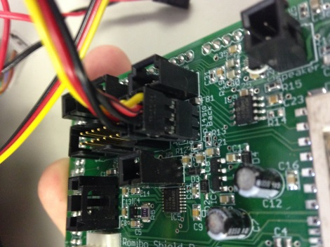  
***dropbox photo + diagram***

Mount the Arduino Board to D plate and screw in.

***photo***

Attach part H

***photo***

Mount Bottom Plate * onto bottom of base.

***photo***

Slide locking plates J1 and J2 over knobs and then slide towards center.

***photo***